**Module-7) React - Applying Redux**

1. **What is Redux?**

**Ans:-** Redux is a JS library for predictable and maintainable global state management. It helps you write applications that behave consistently, run in different environments (client, server, and native), and are easy to test. On top of that, it provides a great developer experience, such as live code editing combined with a time traveling debugger.

**2.** **What is Redux Thunk used for?**

**Ans:**- Redux Thunk middleware allows you to write action creators that return a function instead of an action. The thunk can be used to delay the dispatch of an action, or to dispatch only if a certain condition is met. The inner function receives the store methods dispatch and getState as parameters.Redux thunk used to manage the https request.

**3.** **What is Pure Component? When to use Pure Component over**

**Component?**

**Ans:- React.PureComponent:** It is one of the most significant ways to optimize React applications. By using the pure component, there is no need for shouldComponentUpdate() Lifecycle Method as ReactJS Pure Component Class compares current state and props with new props and states to decide whether the component should re-render or Not.

**Component:**

* Does not implement shouldComponentUpdate by default.
* Always re-renders when parent component re-renders.
* Provides more flexibility and control over the update process.
* Suitable for components where the cost of re-rendering is low or where deep comparison of props and state is required.

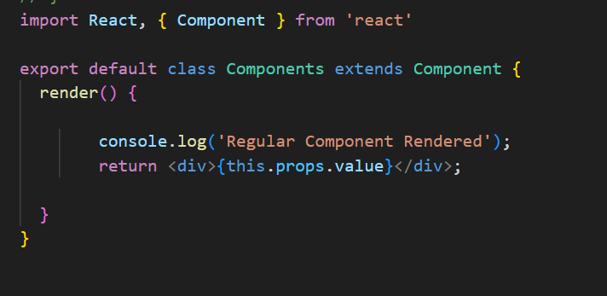

**4. What is the second argument that can optionally be passed**

**To setState and what is its purpose?**

**Ans:-** In React, the setState method can take an optional second argument, which is a callback function. This callback function is executed after the setState operation has been completed and the component has re-rendered.

**Purpose of the Callback:-**

The primary purpose of this callback is to execute code that depends on the state having been updated and the component having re-rendered. Since setState is asynchronous, the callback ensures that you perform actions only after the state change has been applied and the component is in its latest state.

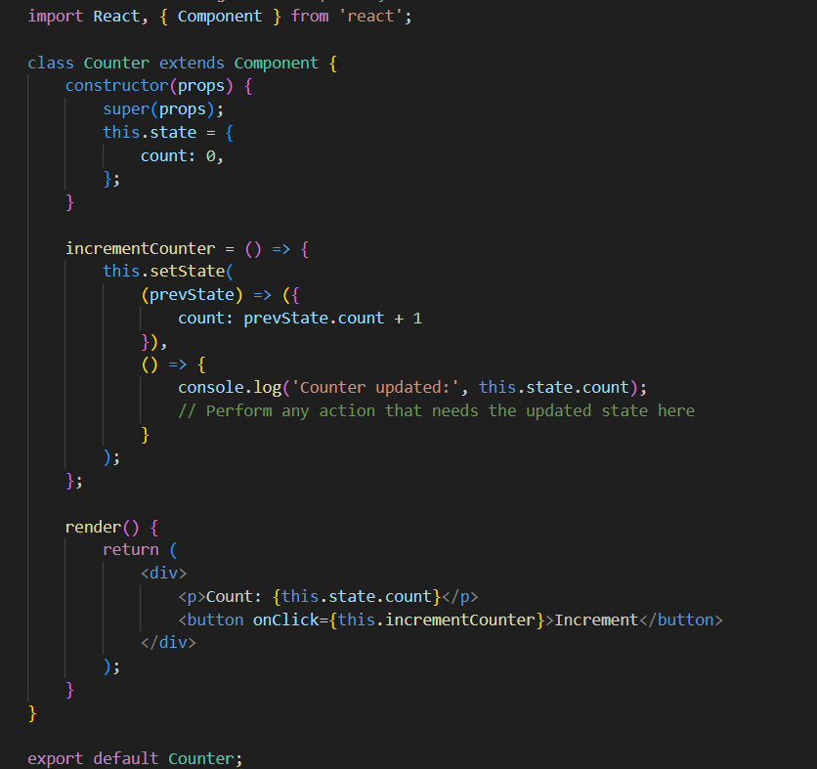

**5. Create a Table and Search data from table using React Js ?**

**Ans:-**

**6.**  **Create Login registration with CRUD Application using API (Redux)**

**Ans:-**